Internet of Things in the Agriculture Industry –

Application of UAV technology for Smart Agriculture

Introduction:

Increments in agricultural production, per hectare of area, have not kept pace with expansions in population and the planet has limited resources of land and water to allow for production. As a result, per-capita cropland has fallen by more than half since 1960, and per-capita production of grains, the basic food, has been falling worldwide for 20 years. [1]

There is an increasing difference between the natural resources required for agriculture and human demand for agriculture. According to the Population Reference Bureau, each day almost a quarter-million people are added to the roughly 6.4 billion who already exist. Yet the stocks of natural resources that support human life-food, fresh water, quality soil, energy, and biodiversity-are being polluted, degraded, and depleted. [2]

We are facing the following major agricultural roadblocks that are hampering productivity.

1. The population is expected to cross 9 billion by 2050. Based on this population estimates, we need to increase our agricultural output by 100% of what we are producing now. The world needs more food and fibre for its increasing population with limited resources.
2. Malnutrition is a common global problem which results in negative health outcomes.

As per World Health Organization, malnutrition accounts for 54% of child mortality in the world. This is approximately equal to 1 million children deaths. [3] As per the estimates, more than 3 billion people in the world are malnourished.

1. The per capita cropland has fallen more than 50 percent since the last 50 years. In addition, unused suitable cropland is distributed in a very uneven manner.
2. Extreme weather conditions in combination with unhealthy human practices has led to a loss in human land. This deterioration affects the integrity of the overall ecosystem. Ina addition, natural forces have led to increase in soil erosion. Natural forces like wind and water results in wearing of topsoil in fields. The rate of topsoil renewal is also very slow.
3. The future expansion of agriculture land is extremely controversial. Majority of the earth surface comprises of non-arable land and water. In addition, there are ecological issues with deforestation that makes it harder to expand arable land.

These roadblocks results in challenges we need to face now and in future. The challenger are listed as below:

1. Since expansion of agricultural land is almost an impossible task, we have to feed the world on existing acreage.
2. The agricultural advancement in production needs to be sustainable to keep pace with the increasing demand in agriculture.
3. Effective utilization of water to ensure that we have adequate water in the future. Water conservation is a very important challenge as it can be seen that we currently face issues like drought in California.
4. Agricultural production requires machinery and these machinery are dependent on energy resources like oil and gas. Since the energy resources are depleting day by day, we need to effectively utilize our machinery in an optimum manner.
5. Extreme weather, diseases, pests, weed, etc. has significantly increase the loss in crop production. We need to minimize the crop loss in an effective manner.

Drones & IoT Technology:

Not With the advent of new technologies such as drones, also known as unmanned aerial vehicles (UAV), the agricultural field can now avoid paying high fees on satellite fly-overs, or manned imagery aircraft in order to track the health of the crops. Drones have found their popularity from You Tube remote controlled videos, or with the concept of package delivery, but many are expecting much of drones usage to come from farming. The drones can be automated to do more regular images and checks on the soil than could be done before, and for a fraction of the cost of conventional methods. The uses will range from high resolution imagery of crop health, to maintaining sprinkler systems and even looking for lost livestock.

With the introduction of internet of things, technology is able to become more efficient and capable more than ever. Internet of things (IoT) is the network of physical objects that contain embedded technology to communicate and sense or interact with their internal states or the external environment (Forbes). The physical objects may include things which are embedded with network connectivity, sensors, electronics, software etc within the object. The way the implication of such embedded software and hardware work is that it improves the integration of data transportation, data manipulation and understanding and customizing accordingly in a very efficient process. The implication and impact of IoT will be significant. That being said in short the impact IoT will have is basically “anything that can be connected, will be connected” (Forbes).

Use of drones can be very significant in the implications of IoT. The fact that drones are easily portable over the air gives it the functionality to be able to do things and cover geographic areas which would be hard or expensive to do so. It is deployable to different locations, capable of carrying flexible payloads and also re-programmable to measure anything for any mission. It works by having a sensor placed on the drone which is connected to the internet. The sensor can capture and measure the data, use the internet to send over to a back-end data infrastructure based in the cloud to do analysis. [4]

Framework of IoT in Agriculture using UAV/Drones -

The framework of industrial internet applied over drone technology is comprised of five phases. Viz. Connect, Capture, Communicate, Analyse and Action.

1. Connect – In this phase, a connection protocol is established among all the different devices which includes drones, sensor, gateways and hubs. This leads to a creation of a connection network which interconnects all the devices.
2. Capture - In this stage, different type of data is captured by the devices and sensors. Field Sensors pick data from the soil that includes data like soil temperature, soil humidity, plant height, etc. The drones captures a lot of weather and climate data like wind speed, temperature, precipitation level, etc. Drones also capture aerial imagery that includes data like drainage mapping, water distribution, etc.
3. Communicate - This is a crucial stage in the framework as this lays foundation to the principle of Internet of Things. At this stage, the field devices like planted sensors and the drones communicate with each other to accumulate data and push this data to a centralized cloud server for processing.
4. Analyse - In the analyse phase, the different types of data that has been collected is mined for insights. This phase is characterized by its use of modelling of data to come with various insights and recommendations. The various type of analysis that is done includes crop yield estimation, diagnosis of diseases, soil erosion, water level estimation and variable fertility rate.
5. Action – In the phase, the prescriptive actions are executed by the drones as directed by the analysis. The various action taken are targeted water irrigation and pesticide deployment, drainage mapping and fertilizer distribution.

The working of a drone can be broke down into 4 components – monitoring, analytics, actions and miscellaneous. In the monitoring phase, various crop data, weather data etc is collected for analytics. In the analytics phase, various descriptive and prescriptive measures are calculated which includes soil erosion, wild game damage, water stress levels, crop yield, etc. Based on these analytics various actions are taken which includes targeted spreading of water and fertilizers. The various data that has been collected is also utilized for research to improve data processing and modelling techniques.

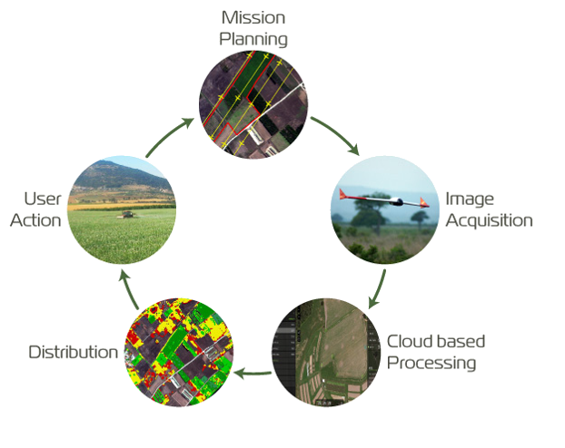The following image explains the working cycle of a drone based on the above framework.

Let’s take an example of how irrigation modelling works. Water is a limited resource and hence its proper utilization is of utmost importance. Additionally, there is fear of leaching of fertilizers in water which leads to less nutritious soil. Therefore, the goal of irrigation modelling is to improve efficiency of irrigation. Let’s look at some examples to clarify this further.

In irrigation modelling, we utilize various data modelling techniques on collected data to create efficient soil and crop models. These models incorporate various data collected from sensors and drones which act as inputs for the model. These data includes various measures like soil temperature, humidity, weather conditions, weather forecast etc. Based on this input, a particular irrigation recipe is created. This recipe defines how much water needs to be provided at a certain location of a whole patch of land among other factors. The drone carries on the task of implementing this recipe on the cropland.

As the cropland might consist of different types of soil and crops, this modelling technique creates a book of recipes for different crops and soil structures. This models are continuously evolving as various measures are utilized to measure the performance of past models. Hence, it is a continuous learning process. This type of irrigation technique results in optimized usage of water, increased growth and increased quality.

Now let’s take a look on how image modelling is utilized in drone’s technology. Image modelling is a very important technique in drone’s technology. Agricultural soil is exposed to many different environmental variables, including drought, storms, and high wind, all of which can lead to dry land, or the presence of parasites in the soil. Unmanned drones, can be fitted with a hyperspectral camera, and spot environmental dangers before they occur. The photo will provide light imagery not visible to the naked eye, and give a new prospective on the health of crops. This in turn allow farmers to spend money and time on areas of the crops that need the most attention, and not waste resources on areas that are doing fine. A few images from the hyperspectral camera are below:

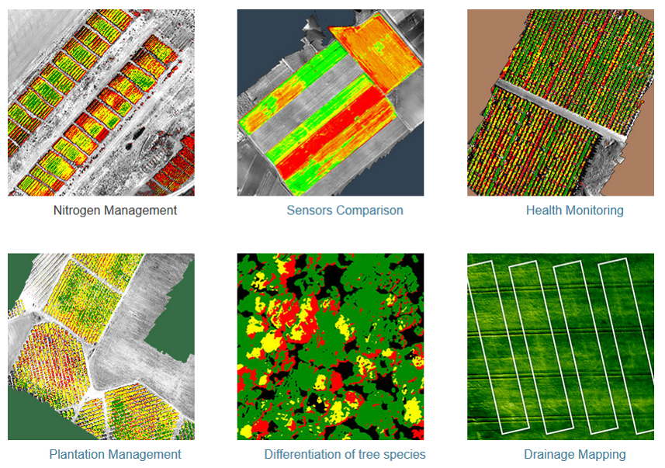

Drones communicate among each other and create a GPS photomapping of the entire field. As you can see above, the multispectral systems create a huge array of descriptive maps which include plant distribution maps, plant health maps, weed identification map, heat maps, fertilizer distribution map, etc. consultants can make recommendations based on software analysis and identify nutrient deficiencies, or view where parasites or organisms are damaging the land.

As you can see above, the various data collected through multispectral processing on aerial imagery are nitrogen management layouts, sensors comparison index, health monitoring maps, plantation management layouts, drainage mapping, etc.

Role of Analytics –

As we have seen above, various prescriptive measures are taken based on the data that has been collected. But the question arises what role does analytics play in this system. Let’s look at the scenarios below expanding on how data mining techniques are used on data to bring insights from data.

1. Climate Prediction/ Weather Forecast - Catastrophic modelling is used to create probabilistic models that predict frequency and severity of extreme weathers.
2. Irrigation Modelling – Various inputs like soil data, climate data etc. are used in combination with regression and simulation techniques to come up with irrigation recipes and irrigation schedule.
3. Field Monitoring using Clustering Algorithms - UAV-Based Remote Sensing Methods utilize clustering algorithms on captured aerial imagery to identify field layouts, crop identification, plantation management and drainage mapping.
4. Weed Identification – Multispectral systems within the drone network are embedded with anomaly detection algorithms that identify and map the spread of weed growth in a crop field. These algorithms compare input layout of crop-row model with the actual aerial imagery and identify weed patches spread across the field.
5. Crop Simulation Modelling - In Crop simulation modelling, we create loops of [simulations model](https://en.wikipedia.org/wiki/Computer_model) that provide estimate of [crop yield](https://en.wikipedia.org/wiki/Crop_yield) as a function of soil conditions, weather conditions and choice of crop management practices. These gives us a good estimate of role of climate change in crop modelling. These models simulate complex interaction within the bio-system and output probabilistic distribution of crop yield.

As you can see from the above examples, application of analytics is turning the agricultural industry upside down. Though the investments can be substantial for farmers in the start, the potential benefits of applying big data technologies on the field are enormous.

Advantages of IoT in Agriculture –

1. The most important advantage of application of drone technology is the significant increase in output of crop yield.
2. The dashboards created with the data collected by sensors helps farmer to make better decisions. These decisions are more scientific as they are data driven instead of gut feelings and hence are more productive in nature.
3. Crop Simulation Modelling is very important for industrial agriculture as it imitates the complex bio system. These models can be effectively used for optimum production planning.
4. Water Conservation – With methods like targeted irrigation, there is a huge savings in the water utilized on the field. These leads to not only in water conservation but also in sustenance in water utilization.
5. Near Zero Fertilizer Leaching – Data driven drainage mapping techniques helps the farmer to prevent or minimize the erosion of water soluble fertilizers thus preserving the soil nutrients essential for crop growth.
6. Reduced Machine Utilization and Cost – As technology allows us to execute targeted farming techniques on patches of land instead of executing these techniques on the whole land spread, it leads to a huge savings in machine and labour utilization. This effectively helps us to save energy and cost, thus making the procedures more sustainable.

Challenges –

1. The Federal Aviation Administration (FAA) is the [national aviation authority](https://en.wikipedia.org/wiki/National_aviation_authority) of the United States, with powers to regulate all aspects of American civil aviation. FAA regulates the permissions and compliances required for the utilization of commercial drones. Currently there are around 32 restrictions with the operation of drones for commercial purposes. The operator is granted an exemption to use a UAV when weighing is less than 55 pounds including payload. The UAV may not be operated at a speed exceeding 87 knots (100 miles per hour). The UA must be operated at an altitude of no more than 400 feet above ground level. The UA must be operated within visual line of sight (VLOS) of the PIC (pilot-in-command) at all times. [5]
2. There needs to be a partner collaboration among all the various stakeholders which include device manufacturers, cloud service providers, analytics companies, etc. Collaboration leads to standardization of the protocols within the system that leads to better adoption and application of technology. However, many companies often create their own protocol systems to create dependency and prevent migration of the consumers to other services.
3. The usage of industrial internet in agriculture should be expandable and integrated to various other activities in the process that includes transportation and storage. Effective implementation of integrated IoT systems in industrial agriculture would lead to increase in agricultural output by increase in crop yield and minimization in transportation losses. This leads to huge savings in cost as well.
4. Currently the drones are not strong against weather conditions as they are affected by heavy rains and winds. There should be advancement in drone manufacturing that would be able to provide more robust drones in future.
5. Though the agricultural technology is advancing, many third world countries are not able to adopt the technology as it requires significant capital investment at the start. There should be standardization of technology in future so that device manufactures incur low cost on production because of economies of sale and thus be able to provide technology at a cheaper rate.
6. There should be advancement in the algorithmic models and data processing techniques as the real insight lies in the data. Hence, there should be significant investment on analytics techniques compared to hardware technology so that significant business values can be created at a cheaper rate.

Bibliography

1. <http://worldwatch.org/node/554>
2. <http://worldwatch.org/node/554>
3. Walker, [edited by] Christopher Duggan, John B. Watkins, W. Allan (2008). Nutrition in paediatrics: basic science, clinical application. Hamilton: BC Decker. pp. 127–141. ISBN 978-1-55009-361-2.
4. http://droneanalyst.com/2014/12/01/drones-are-the-future-of-iot/
5. <https://www.faa.gov/uas/legislative_programs/section_333/333_authorizations/media/Triple-J-Water-Works-16544.pdf>